# Router IPv6 Configuration

Router>en

Router#conf t

Enter configuration commands, one per line. End with CNTL/Z.

Router(config)#ipv6 unicast-routing

Router(config)#int g0/0

Router(config-if)#ipv6 address 2001:DB8:1:1::1/64

Router(config-if)#ipv6 address FE80::1 LINK-LOCAL

Router(config-if)#NO SHUTDOWN

Router(config-if)#

%LINK-5-CHANGED: Interface GigabitEthernet0/0, changed state to up

%LINEPROTO-5-UPDOWN: Line protocol on Interface GigabitEthernet0/0, changed state to up

Router(config-if)#EXIT

Router(config)#INT G0/1

Router(config-if)#ipv6 address 2001:DB8:1:2::1/64

Router(config-if)#ipv6 address FE80::1 LINK-LOCAL

Router(config-if)#NO SHUTDOWN

Router(config-if)#EXIT

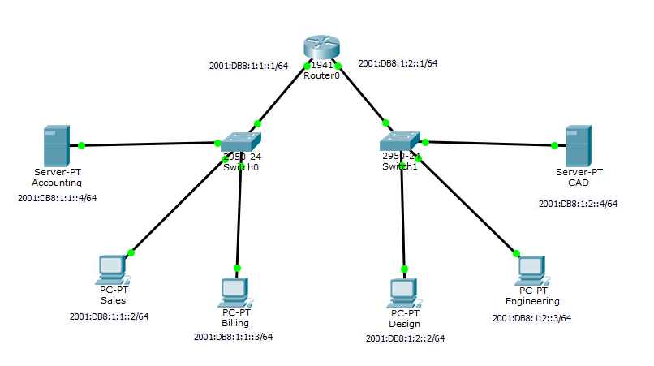

## Assigning IP Addresses to End Terminals

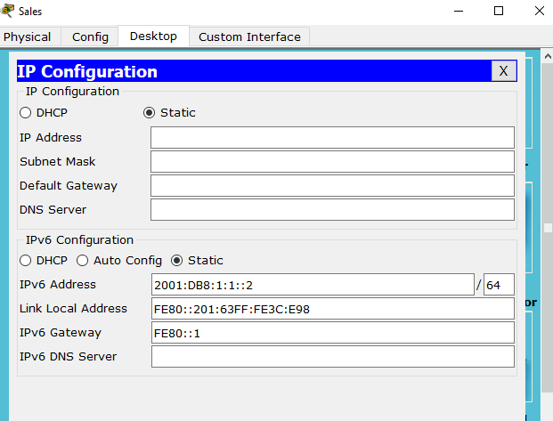

## Accessing Web browser from Sales

